**Australian Islamic College 2020**

**ATAR Chemistry Units 3 and 4**

**Task 8A (Weighting: 2%)**

**Organic Chemistry Test 1**

Test Time: 25 minutes

Please do not turn this page until instructed to do so.

|  |  |
| --- | --- |
| **First Name** | **Surname** |
| **ANSWERS** |  |

|  |
| --- |
| **Teacher** |
|  |

|  |  |
| --- | --- |
| **Mark / 25** | **Percentage** |
|  |  |

Equipment allowed: Pens, pencils, erasers, whiteout, correction tape, rulers and non-programmable calculators permitted by the Schools Curriculum and Standards Authority.

**Special conditions**:

2 marks will be deducted for failing to write your full name on this test paper.

**Teacher help**: Your teacher can only help you during your test in one situation.

If you believe there is a mistake in a question show your teacher and your teacher will tell you if there is a mistake in the question and if appropriate, how to fix that mistake.

**Spelling of Science words** must be correct. Unless otherwise indicated, science words with more than one letter wrong (wrong letter and/or wrong place) will be marked wrong.

Unless otherwise stated, **equations** must be written balanced and with correct state symbols or they will be marked wrong.

Questions must be answered in this booklet.

Total marks: 25

**PART ONE: MULTIPLE CHOICE QUESTIONS (3 MARKS)**

**Circle the correct answer on this page.**

1. A student wants to use a physical property to distinguish between two alcohols, octan-1-ol and propan-1-ol. Both alcohols are colourless liquids at standard laboratory conditions (SLC).

The student should use

* 1. Density because propan-1-ol has a much higher density than octan-1-ol.
  2. **Boiling point because octan-1-ol has a higher boiling point than propan-1-ol.**
  3. Electrical conductivity because octan-1-ol has a higher conductivity than propan-1-ol.
  4. Spectroscopy because it is not possible to distinguish between the alcohols using their physical properties.

1. How many structural isomers are there with the molecular formula C5H11Br?
   1. 6
   2. 7
   3. **8**
   4. 9
2. Which two words most correctly describe the molecule shown below?

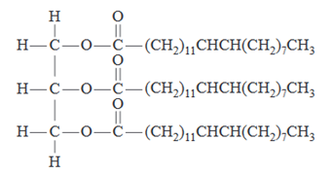

* 1. Alcohol, carboxylic acid.
  2. Glycerol, lipid.
  3. **Ester, triglyceride.**
  4. Fatty acid, soap.

**PART TWO: SHORT ANSWER QUESTIONS (22 MARKS)**

1. The following table shows different representations of organic molecules, using butanoic acid as an example.

Refer to the ways that organic molecules can be represented when answering this question.

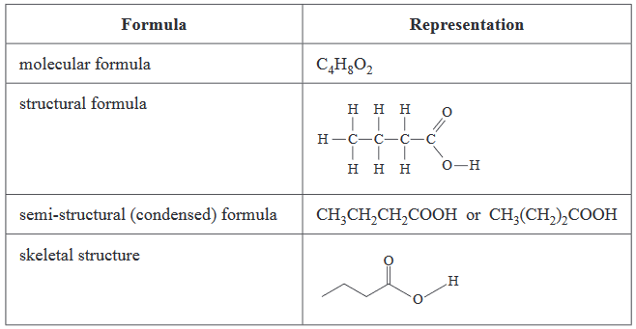

* 1. Draw the structural formula of 2-methylpropan-2-ol.

(1 mark)

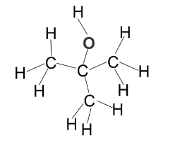

**Marker: All atoms and all bonds must be drawn. Bond angles need not be correct. No part marks.**

* 1. Give the molecular formula of but-2-ene.

(1 mark)

**C4H8**

**No part marks.**

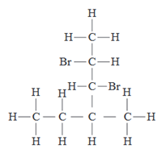

* 1. Give the IUPAC name of the compound that has the structural formula shown above.

(1 mark)

**2,3-dibromo-4-methylhexane**

**Marker: All parts of the name must be correct, including commas and hyphens. No part marks.**

* 1. Write the semi-structural formula for the structural isomer of propanal that is a ketone.

(1 mark)

**CH3COCH3 (also accept H3CCOCH3)**

**No part marks.**

* 1. Draw the structural formula of another structural isomer of propanal that is not a ketone or an aldehyde.

(1 mark)

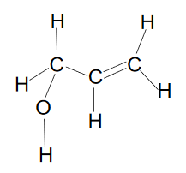

**Marker: All atoms and all bonds must be drawn. Bond angles need not be correct. No part marks.**

**Hydroxyl group can be on any carbon.**

**Note: Also accept the structural formula of cyclopropanol.**

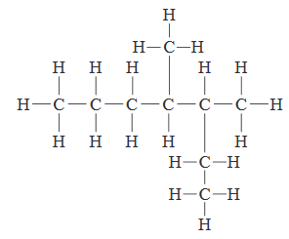

* 1. Give the IUPAC name of the compound with the structural formula shown above.

(1 mark)

**3,4-dimethylheptane**

**Marker: All parts of the name must be exactly correct, including commas and hyphens and with no spelling mistakes. No part marks.**

1. Substance P is a molecule found in the human body. It is associated with inflammation and pain.

The structure of substance P is shown below.

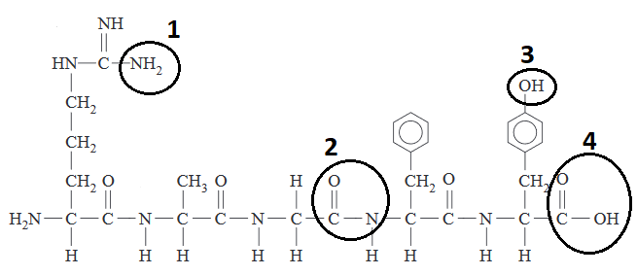

Name the numbered functional groups. Spelling must be exactly correct.

(4 marks)

Functional group 1:

**Amine / Amino**

Functional group 2:

**Amide**

Functional group 3:

**Alcohol / Hydroxy / Hydroxyl**

Functional group 4:

**Carboxylic acid / Carboxyl**

**Marker: Spelling must be exactly correct. No part marks.**

1. Mixtures of propan-2-ol and propanone can be separated by distillation due to their different boiling points. Explain why these compounds have such different boiling points even though they have very similar molar masses.

(3 marks)

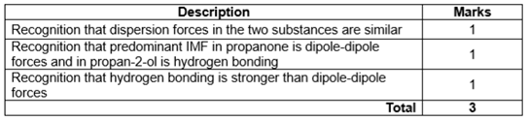

1. List butane, butan-2-ol and butanone from most soluble to least soluble in water.

(1 mark)

**Butan-2-ol, butanone, butane.**

**No part marks.**

1. Ethanol and methanol are completely miscible (soluble) in water.
   1. By referring to any intermolecular forces present, describe the dissolving process as ethanol is added to water.

(3 marks)

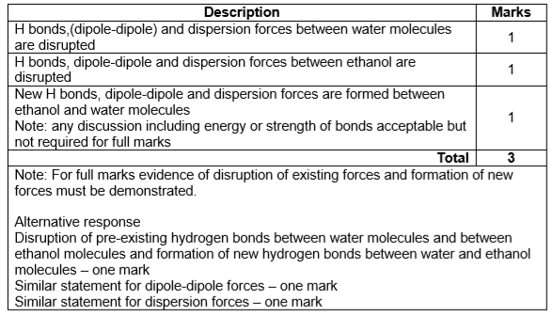

* 1. Explain what happens to the solubility of alcohols in water as the hydrocarbon chain length increases.

(3 marks)

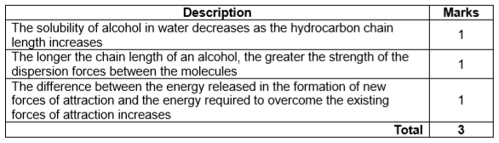

* 1. For each of the following substances, list all force/s of attraction formed between the solute and the solvent when each substance dissolves in water.

(2 marks)

|  |  |
| --- | --- |
| **Substance** | **Force/s of Attraction With Water** |
| Propanal | **Hydrogen bonding, dipole-dipole forces, dispersion forces.** |
| Methanoic acid | **Hydrogen bonding, dipole-dipole forces, dispersion forces.** |

**Marker: One mark each. All forces of attraction for each substance must be stated for the mark to be awarded.**